[YOUR PROJECT NAME]
Analysis Model

Submitted to:

Asst. Prof. Ma. Rowena C. Solamo
Faculty Member
Department of Computer Science
College of Engineering
University of the Philippines, Diliman

Submitted by:
[List of Members in Alphabetical Order]

In partial fulfillment of Academic Requirements
for the course
CS 191 Software Engineering I
of the
1st Semester, AY 2014-2015
Revision Control

History Revision:
Revision Date | Person Responsible | Version  Number | Modification
MM/DD/YY | Juan de la Cruz | 1.0 | Initial Document; Version number should match the one found in the footer.

System Name: [Name of the System eg. Athlete Record Maintenance System]

Description: [Brief Description of the System in 3-7 sentences.]

Class Diagram:

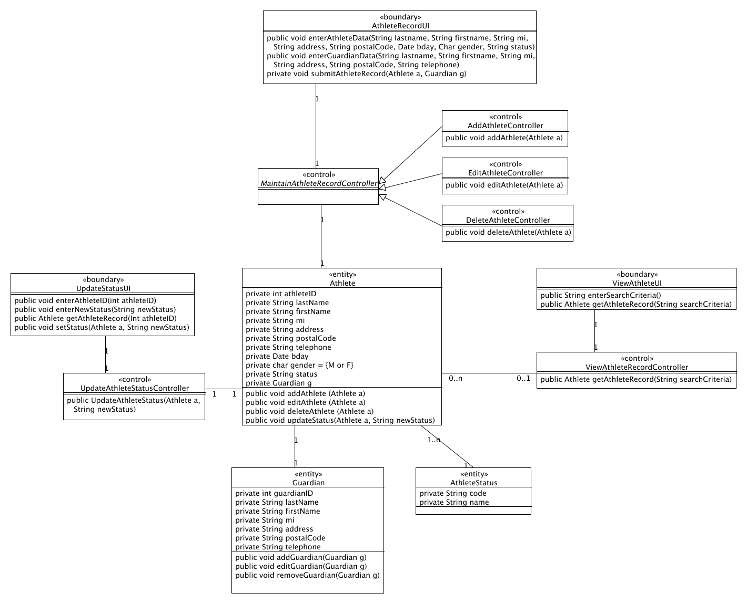

Boundary Classes:

Class Name | Description

Control Classes:

Class Name | Description

Entity Classes:

Class Name | Description

